Depth

Definition
# Source: AI Source: Provided by: [Data Path: Persons Table -> ID Column: 1, Name_En Column: Motasem Essam] -> From: [ChatGPT] on [7/20/2026]
In geometry, depth is the linear distance measured from the front of an object or region toward the back.
In simple terms:
Depth describes how far an object extends from front to back.
$$\boxed{\text{Depth}=\text{Front-to-Back Distance}}$$
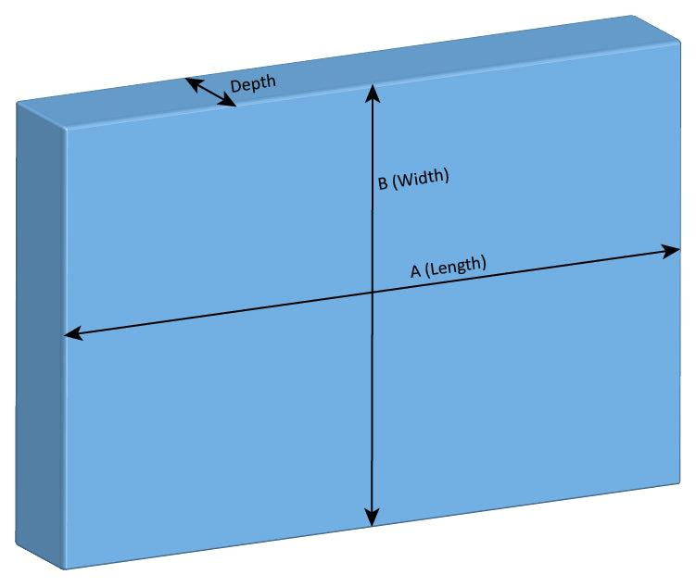
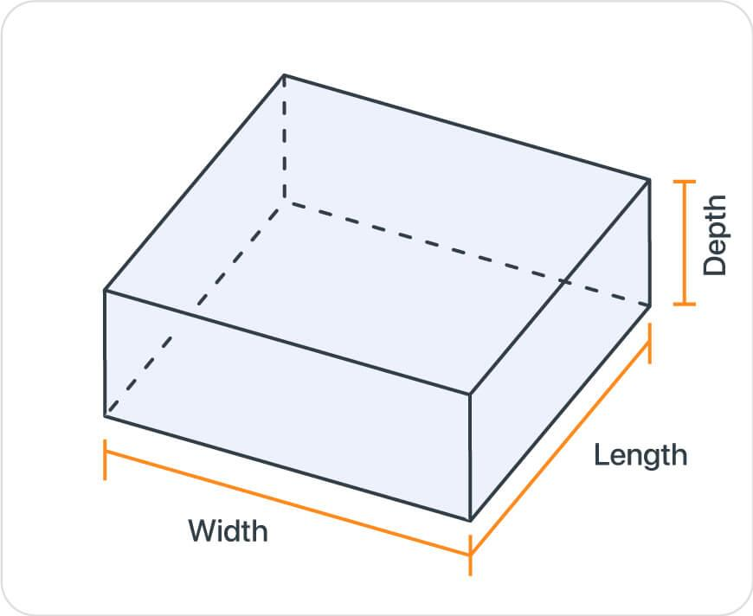
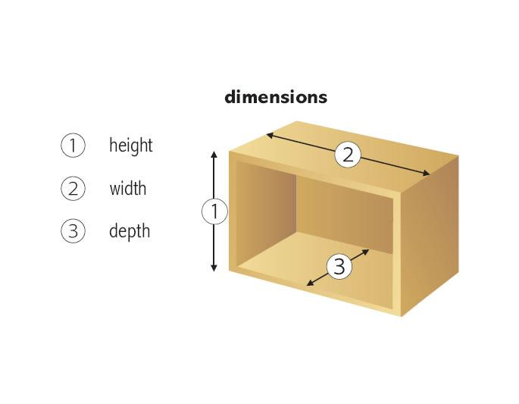
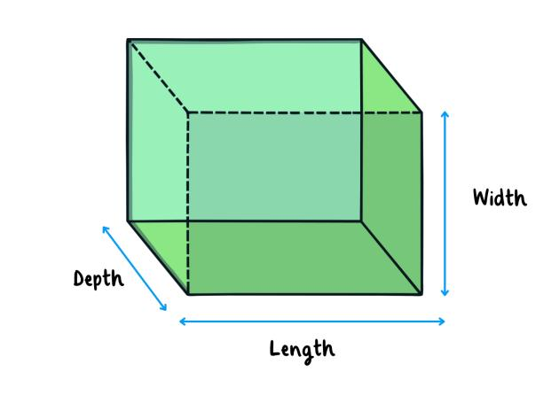
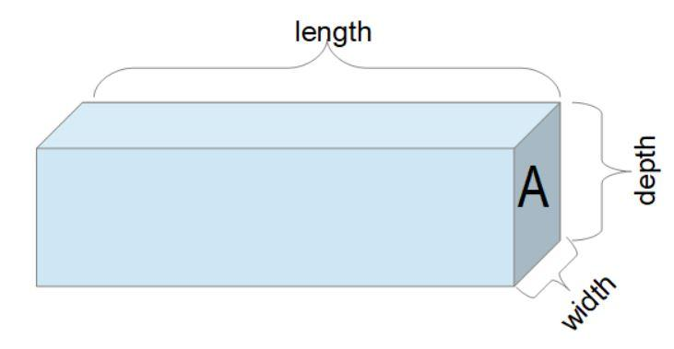
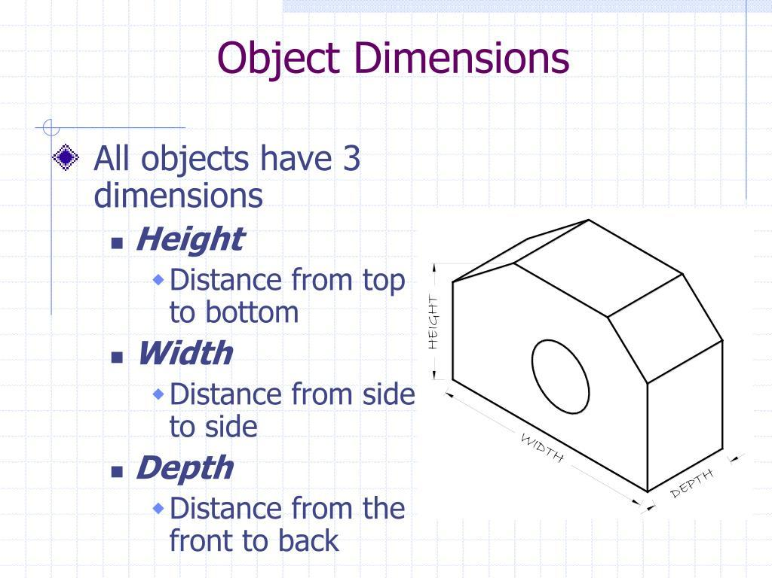

Characteristics
# Source: AI Source: Provided by: [Data Path: Persons Table -> ID Column: 1, Name_En Column: Motasem Essam] -> From: [ChatGPT] on [7/20/2026]
Depth:
- Is a linear measurement.
- Describes the front-to-back extent of an object.
- Is often represented by $d$.
- Is commonly used for three-dimensional objects.
- Is measured in linear units.
- Can be used in calculations of volume and surface area.
- Depends on the orientation and viewpoint of the object.
$$\boxed{d≥0}$$

Depth in Plane Geometry
# Source: AI Source: Provided by: [Data Path: Persons Table -> ID Column: 1, Name_En Column: Motasem Essam] -> From: [ChatGPT] on [7/20/2026]
For a purely 2D figure, depth normally does not represent an independent geometric dimension because a plane figure has only two dimensions.
For example, a rectangle has:
$$\boxed{\text{Length}×\text{Width}}$$
but no independent depth.
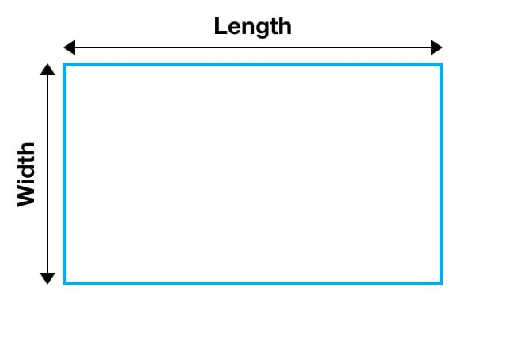
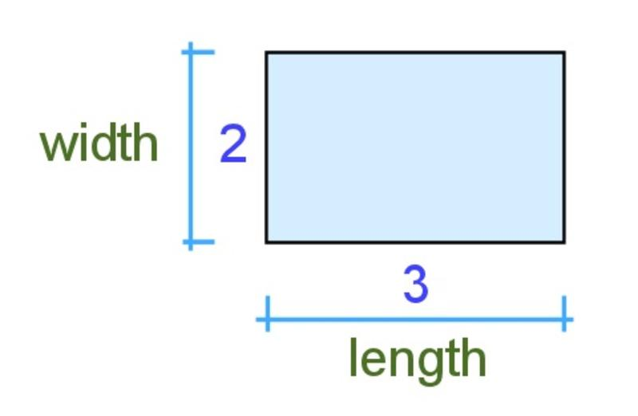
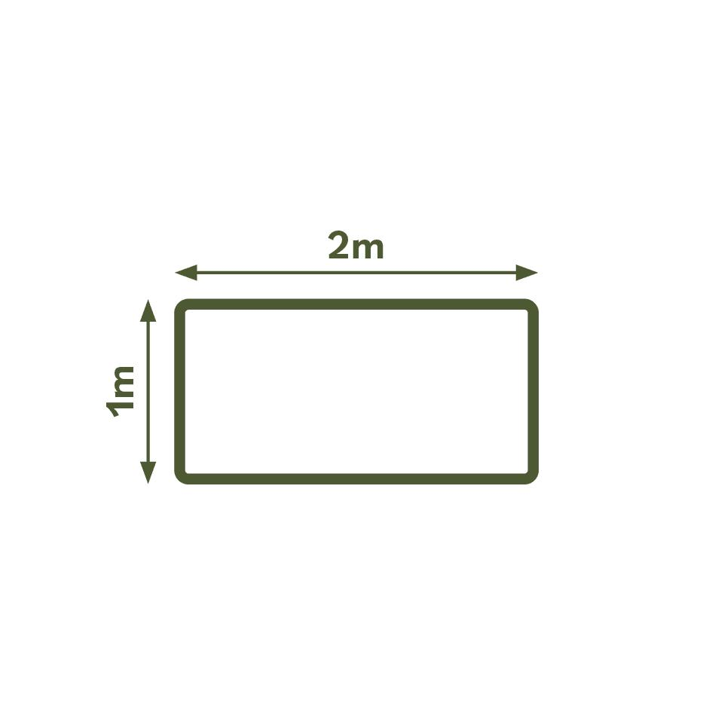
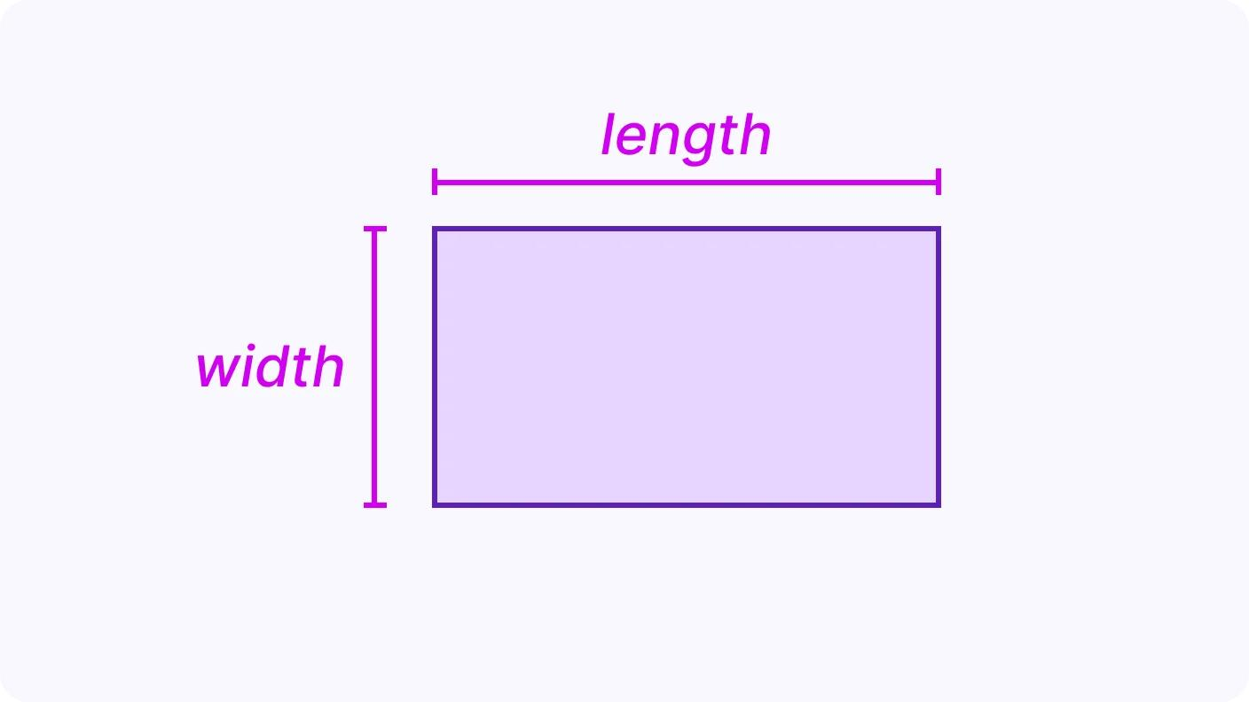
Depth becomes an independent dimension when the figure is considered as a 3D object.

Depth in Solid Geometry

1. Rectangular Prism
# Source: AI Source: Provided by: [Data Path: Persons Table -> ID Column: 1, Name_En Column: Motasem Essam] -> From: [ChatGPT] on [7/20/2026]
A rectangular prism can be described using:
$$\boxed{V=lwd}$$
where:
- $l$ = length
- $w$ = width
- $d$ = depth
Alternatively, height may be used:
$$\boxed{V=lwh}$$
depending on the orientation.

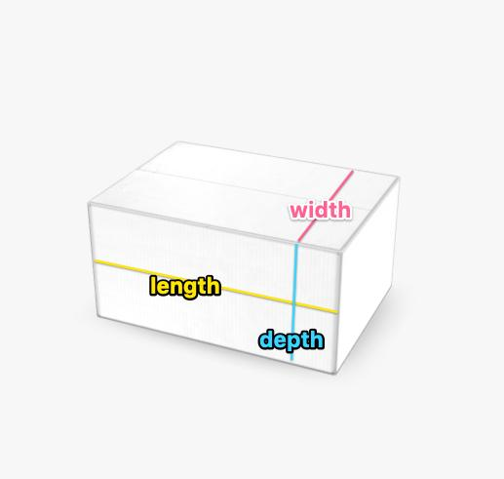

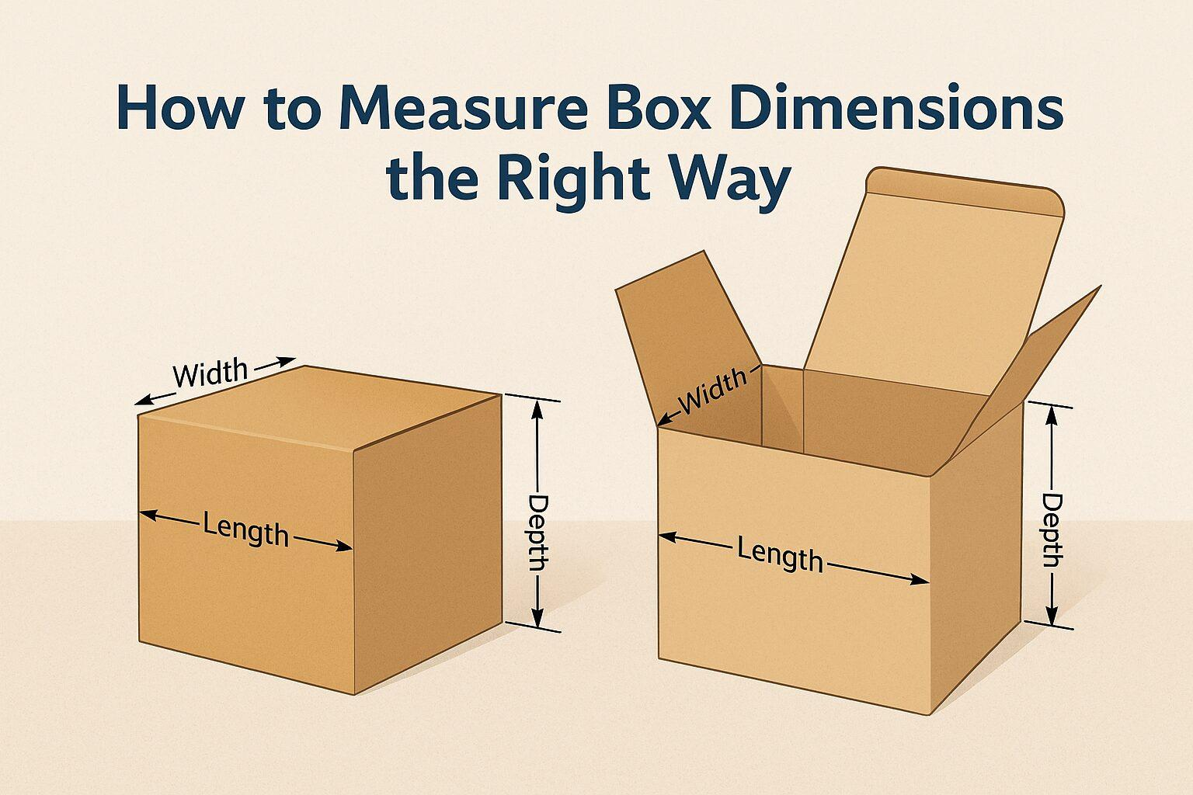
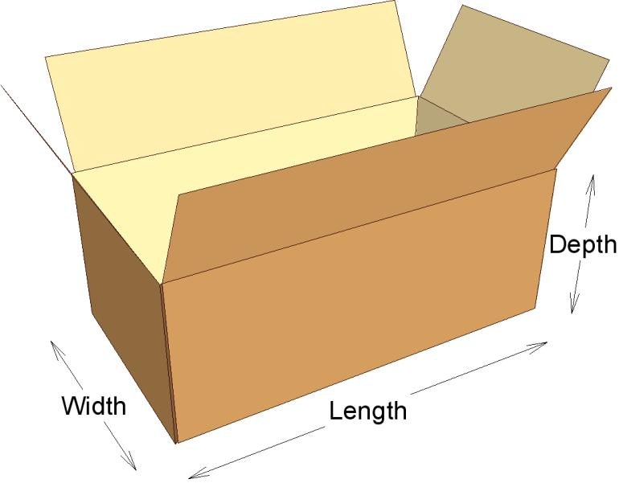
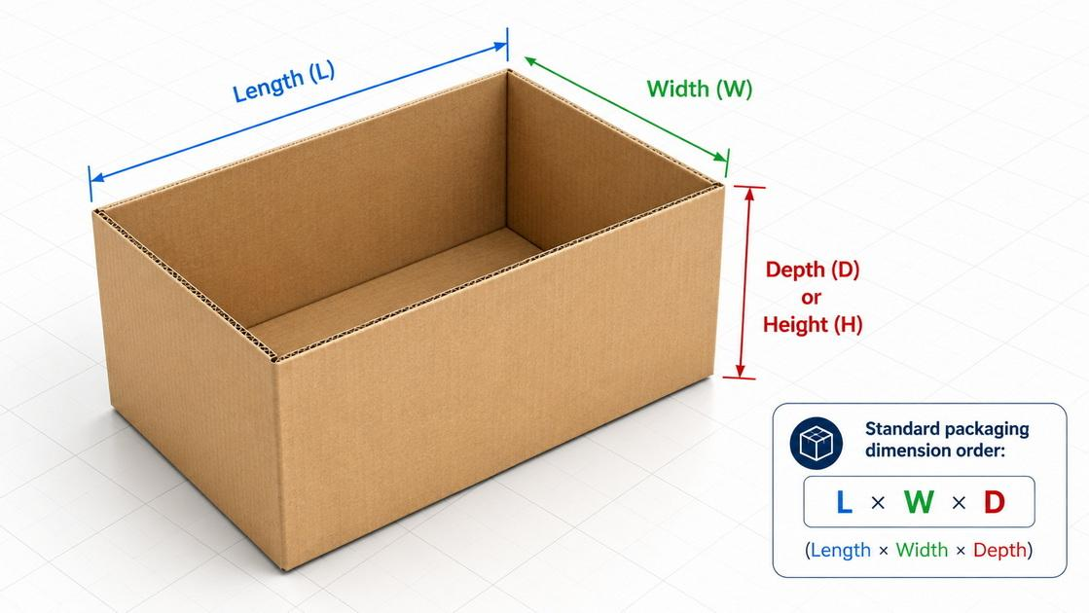

2. Cube
# Source: AI Source: Provided by: [Data Path: Persons Table -> ID Column: 1, Name_En Column: Motasem Essam] -> From: [ChatGPT] on [7/20/2026]
For a cube, all three dimensions are equal:
$$\boxed{l=w=d=s}$$
Therefore:
$$V=s^{3}$$
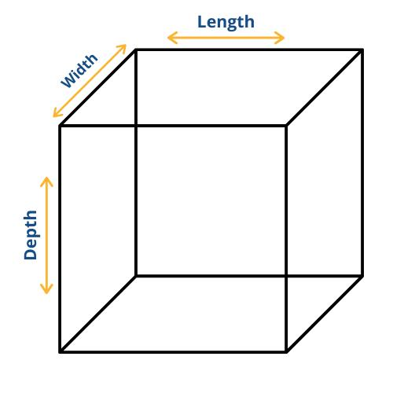
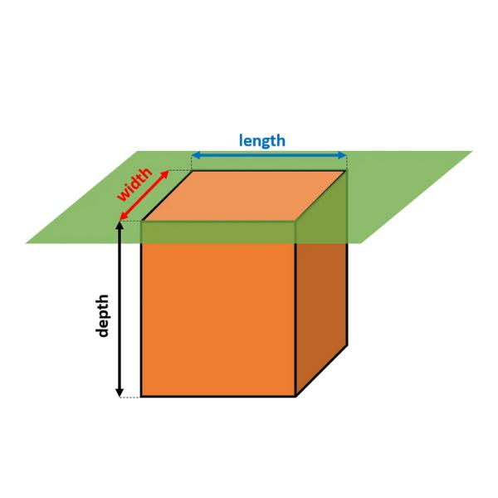
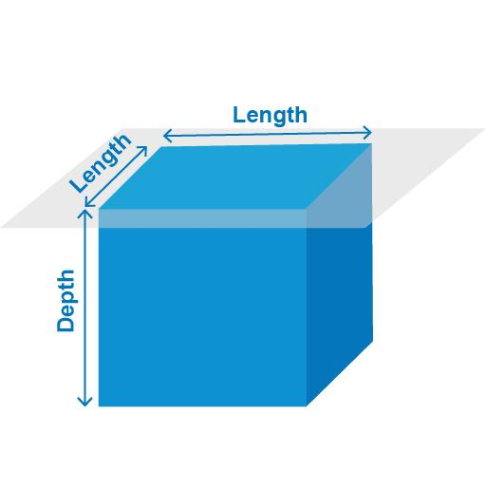

3. Room or Rectangular Space
# Source: AI Source: Provided by: [Data Path: Persons Table -> ID Column: 1, Name_En Column: Motasem Essam] -> From: [ChatGPT] on [7/20/2026]
A rectangular room can be described using:
$$\boxed{V=lwd}$$
where depth represents the distance from the front wall toward the back wall.
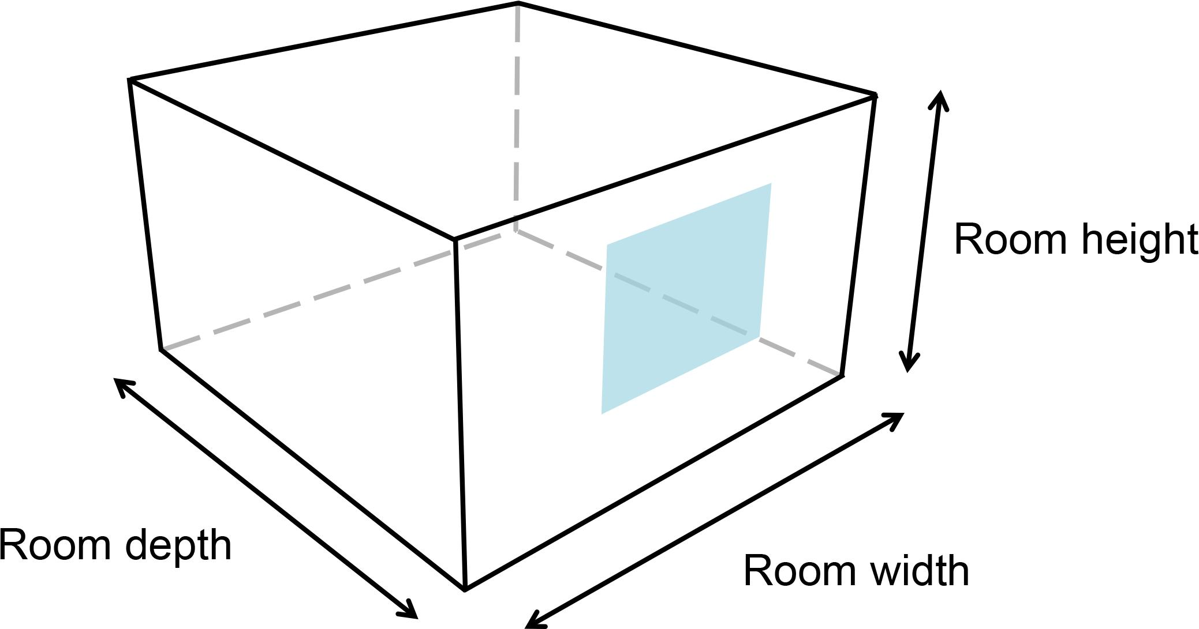
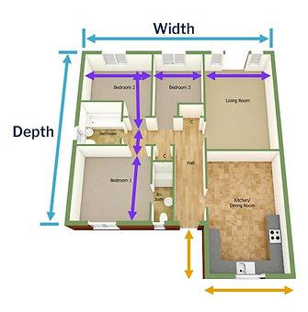

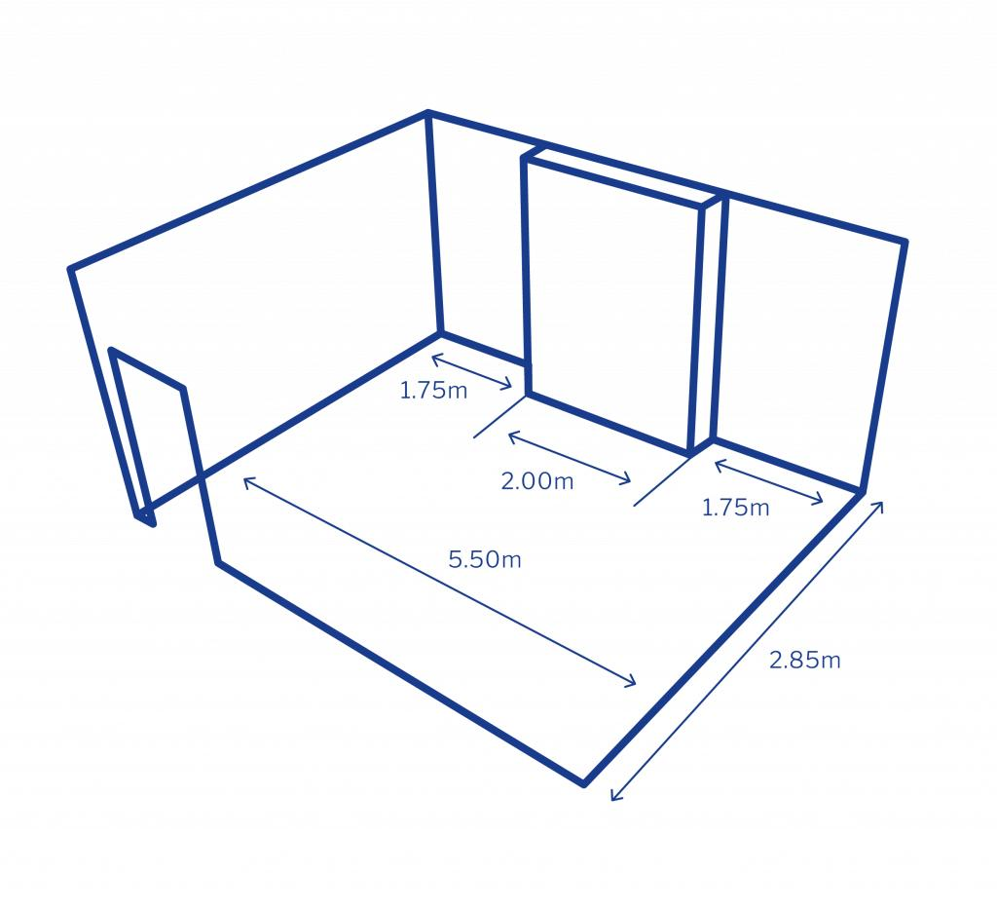

Depth and Volume
# Source: AI Source: Provided by: [Data Path: Persons Table -> ID Column: 1, Name_En Column: Motasem Essam] -> From: [ChatGPT] on [7/20/2026]
Depth is particularly important in volume calculations.
For a rectangular solid:
$$\boxed{V=lwd}$$
If length and width remain constant:
$$V∝d$$
So increasing the depth increases the volume proportionally.
For example, if:
$$l=10, w=4$$
then:
$$V=40d$$
Therefore:
$$d=2⇒V=80$$
and:
$$d=5⇒V=200$$

Depth and Surface Area
# Source: AI Source: Provided by: [Data Path: Persons Table -> ID Column: 1, Name_En Column: Motasem Essam] -> From: [ChatGPT] on [7/20/2026]
For a rectangular prism:
$$\boxed{SA=2\left(lw+ld+wd\right)}$$
Thus, depth contributes to the areas of the front/back, top/bottom, or side faces depending on the chosen orientation.

Depth vs. Width
# Source: AI Source: Provided by: [Data Path: Persons Table -> ID Column: 1, Name_En Column: Motasem Essam] -> From: [ChatGPT] on [7/20/2026]
Depth and width are both transverse dimensions, but they describe different directions depending on the object's orientation.
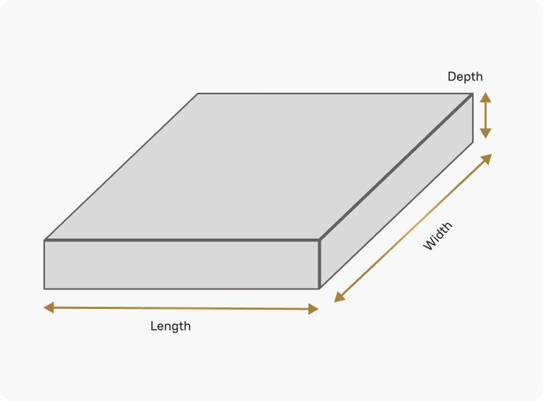





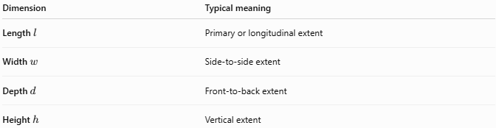
Dimension | Typical meaning
Length $l$ | Primary or longitudinal extent
Width $w$ | Side-to-side extent
Depth $d$ | Front-to-back extent
Height $h$ | Vertical extent
These terms are conventional, not absolute. Rotating the object can change which dimension is naturally called its width, depth, or length.

Depth vs. Height
# Source: AI Source: Provided by: [Data Path: Persons Table -> ID Column: 1, Name_En Column: Motasem Essam] -> From: [ChatGPT] on [7/20/2026]
Depth and height generally represent perpendicular directions:
$$\boxed{d⊥h}$$
For example:
- Height → bottom to top.
- Depth → front to back.

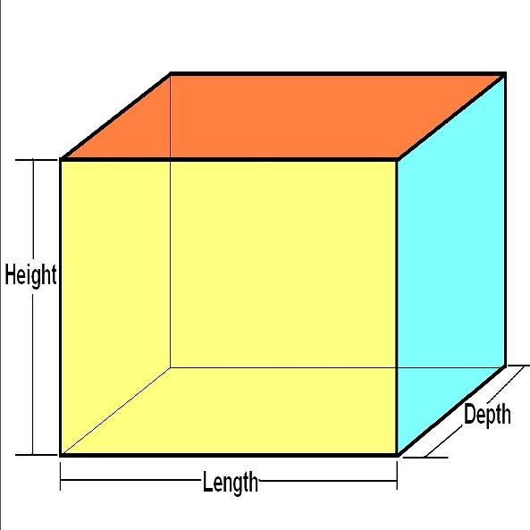
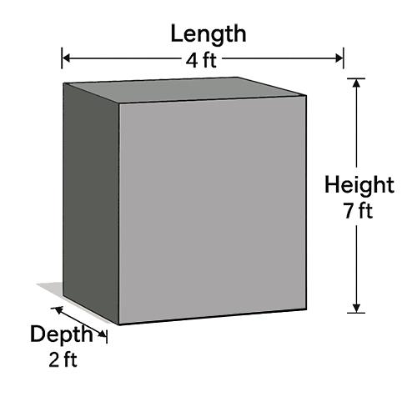

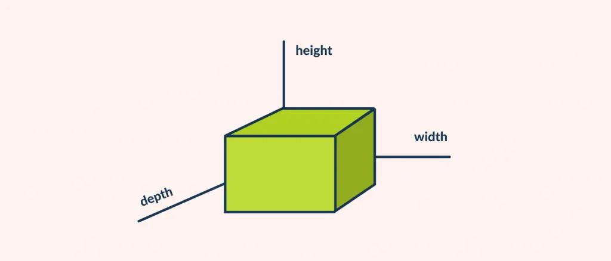

Depth vs. Length
# Source: AI Source: Provided by: [Data Path: Persons Table -> ID Column: 1, Name_En Column: Motasem Essam] -> From: [ChatGPT] on [7/20/2026]
Both are linear dimensions, but they normally describe different orientations.
$$\boxed{\text{Length}=\text{primary extent}} \\ \boxed{\text{Depth}=\text{front-to-back extent}}$$
However, the distinction depends on how the object is positioned and described.

Depth in Measurement
# Source: AI Source: Provided by: [Data Path: Persons Table -> ID Column: 1, Name_En Column: Motasem Essam] -> From: [ChatGPT] on [7/20/2026]
Depth is a one-dimensional quantity.
Its dimensional representation is:
$$\boxed{\left[d\right]=L}$$
where $L$ is the dimension of length.
Common units include:
- millimeters (mm)
- centimeters (cm)
- meters (m)
- kilometers (km)
- inches (in)
- feet (ft)
- yards (yd)
Correct:
$$d=20\text{ cm}$$
Incorrect:
$$d=20{\text{ cm}}^{2}$$
because ${\text{cm}}^{2}$ represents area.

Depth in Irregular 3D Objects
# Source: AI Source: Provided by: [Data Path: Persons Table -> ID Column: 1, Name_En Column: Motasem Essam] -> From: [ChatGPT] on [7/20/2026]
For irregular objects, there may not be one uniquely defined depth.
Depending on the application, one might measure:
- Maximum depth.
- Minimum depth.
- Local depth.
- Average depth.
- Depth at a specified point.
- Perpendicular depth.
- Bounding-box depth.
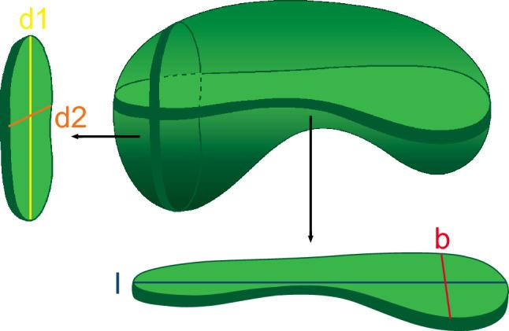

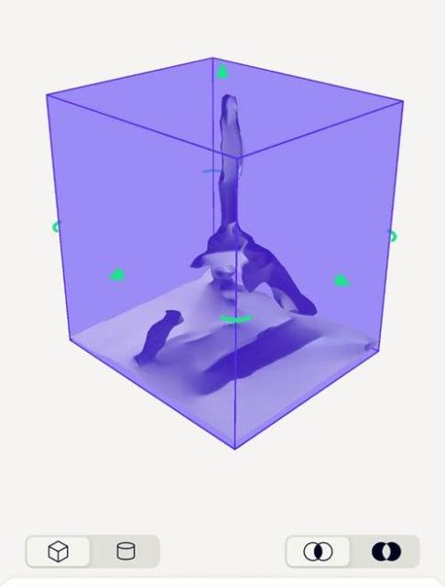
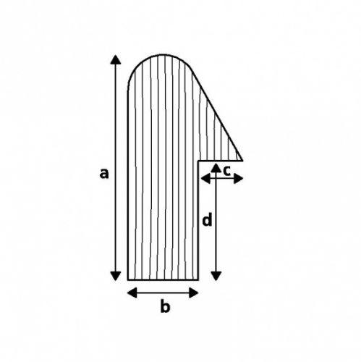
Therefore, for an irregular object, the exact definition of depth should be specified.

Depth in Coordinate Geometry
# Source: AI Source: Provided by: [Data Path: Persons Table -> ID Column: 1, Name_En Column: Motasem Essam] -> From: [ChatGPT] on [7/20/2026]
In three-dimensional coordinate geometry, depth can correspond to one of the coordinate directions.
A point can be represented as:
$$P\left(x,y,z\right)$$
where the three coordinates represent distances along three mutually perpendicular axes.
For example:
$$\boxed{x=\text{left-right}, y=\text{up-down}, z=\text{front-back}}$$
Depending on the coordinate convention, the (z)-axis can represent depth.
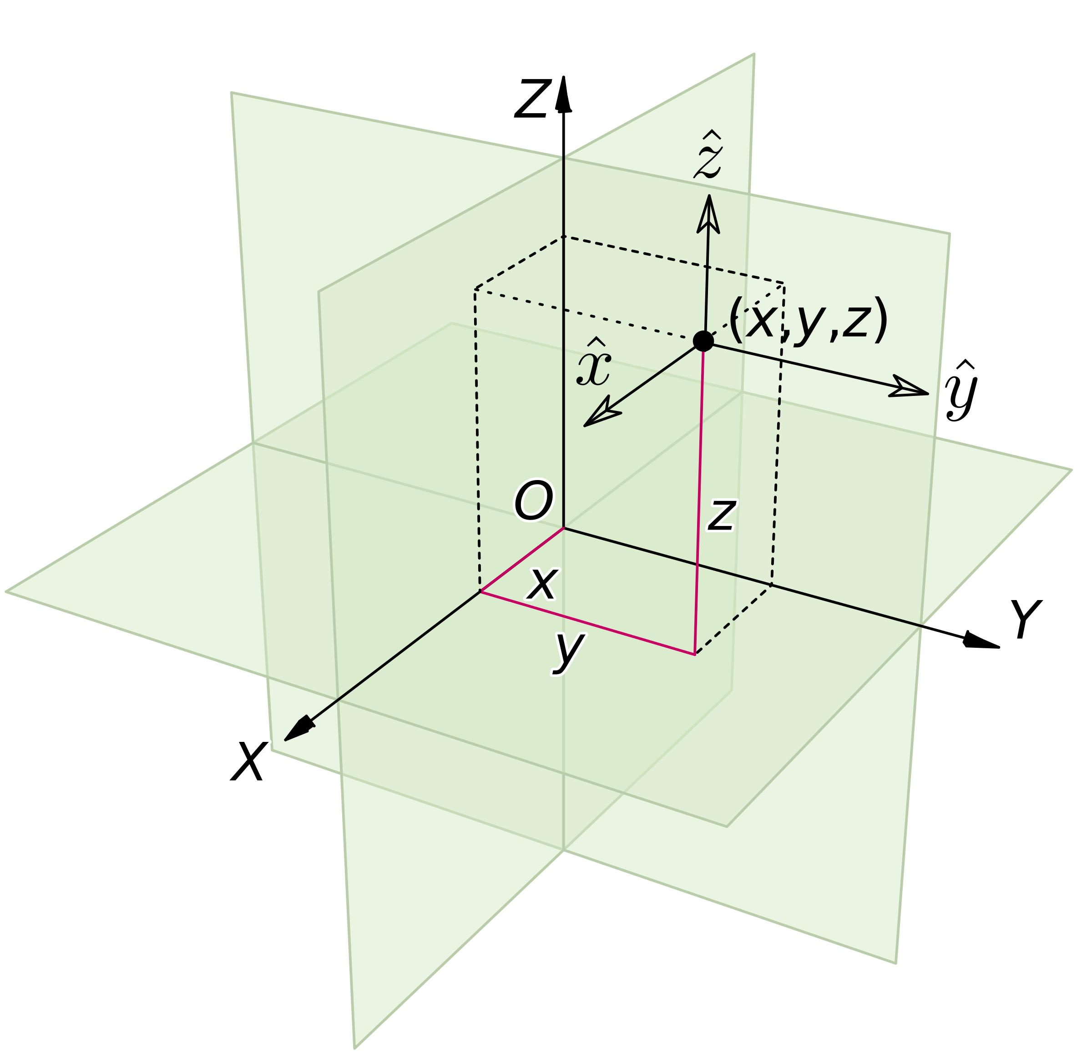
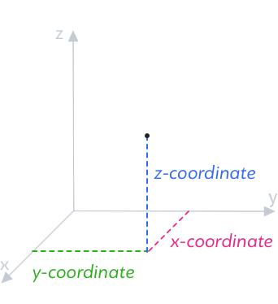
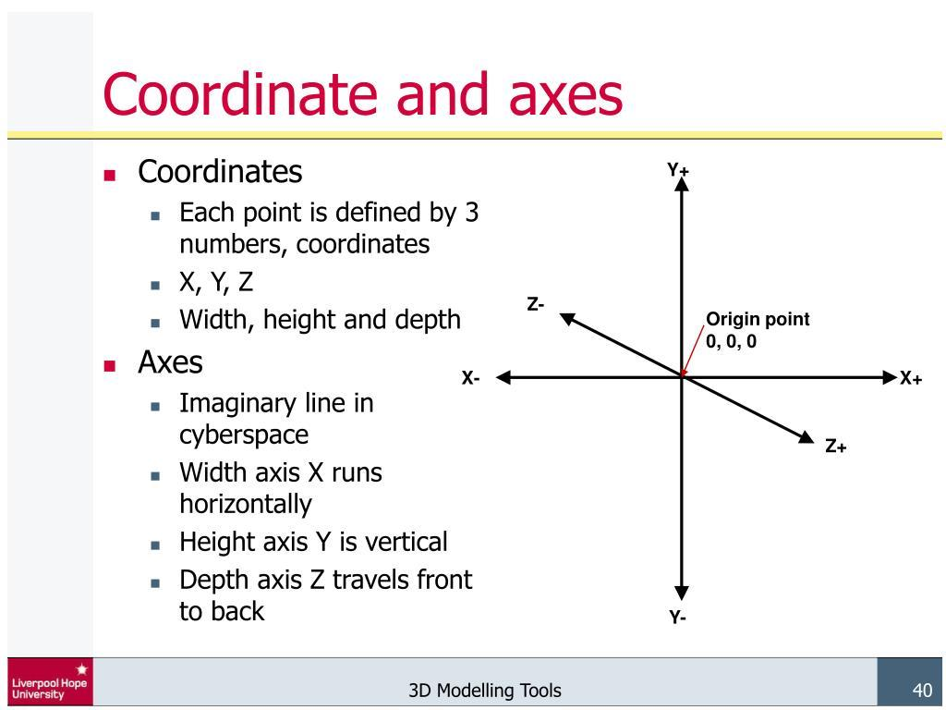
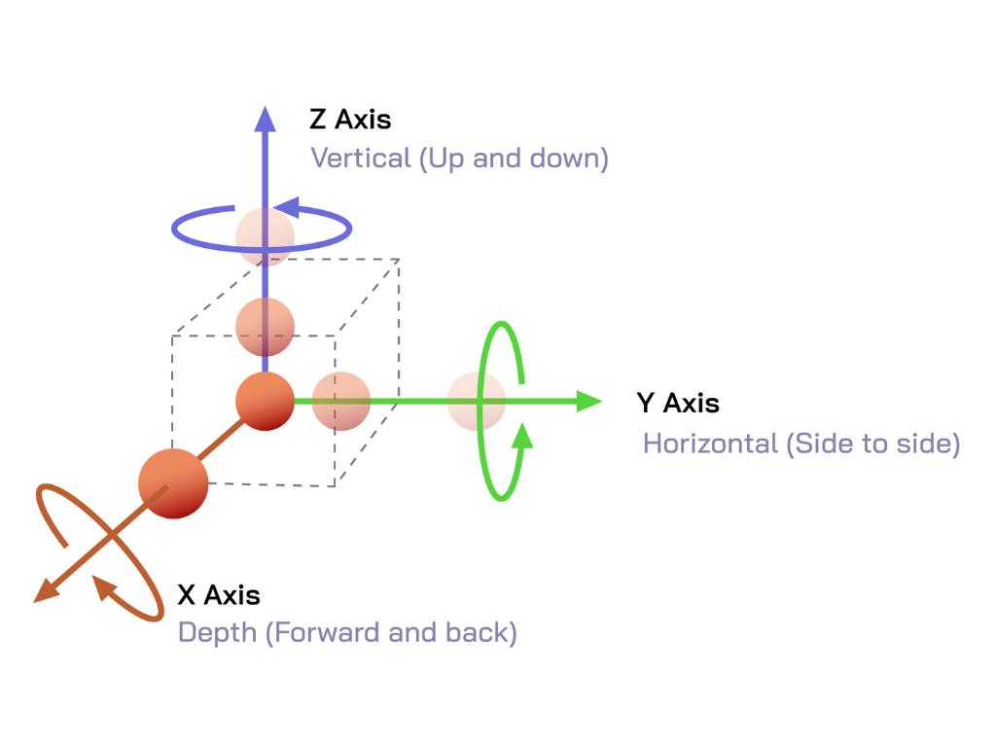
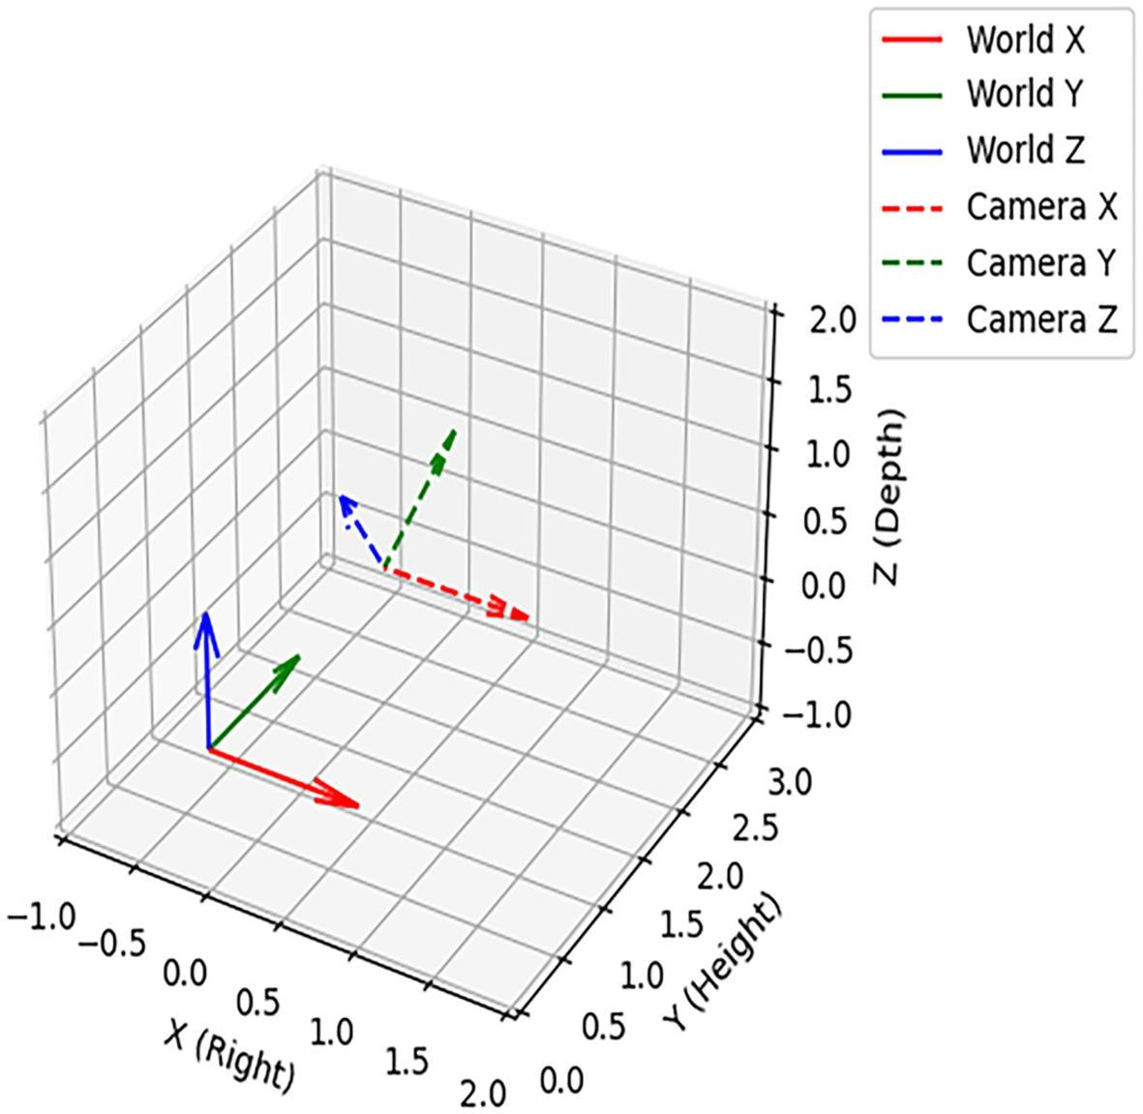

Depth vs. Distance
# Source: AI Source: Provided by: [Data Path: Persons Table -> ID Column: 1, Name_En Column: Motasem Essam] -> From: [ChatGPT] on [7/20/2026]
Depth is a particular type of distance: a distance measured in a designated front-to-back direction.
Thus:
$$\boxed{\text{Depth}⊂\text{Linear Distance}}$$
More precisely:
$$\boxed{\text{Depth}=\text{Distance Along the Front-to-Back Direction}}$$

Applications
# Source: AI Source: Provided by: [Data Path: Persons Table -> ID Column: 1, Name_En Column: Motasem Essam] -> From: [ChatGPT] on [7/20/2026]
Depth is important in:
- Geometry
- Measurement Theory
- Engineering
- Architecture
- Technical Drawing
- Mechanical Design
- Construction
- Manufacturing
- Robotics
- Computer Graphics
- CAD (Computer-Aided Design)
- 3D Modeling
- Surveying

Advantages
# Source: AI Source: Provided by: [Data Path: Persons Table -> ID Column: 1, Name_En Column: Motasem Essam] -> From: [ChatGPT] on [7/20/2026]
Understanding depth helps to:
- Describe the front-to-back dimension of objects.
- Define the three-dimensional size of objects.
- Calculate volume and surface area.
- Support accurate 3D modeling and technical drawings.
- Determine available space and clearances.
- Describe spatial relationships between objects.
- Support engineering, architectural, and mechanical designs.

Limitations
# Source: AI Source: Provided by: [Data Path: Persons Table -> ID Column: 1, Name_En Column: Motasem Essam] -> From: [ChatGPT] on [7/20/2026]
Depth:
- Is a one-dimensional measurement.
- Depends on the chosen orientation or viewpoint.
- Does not by itself describe the complete size of a 3D object.
- May be difficult to define for irregular objects.
- Often requires a reference direction or surface.
- Does not describe area or volume by itself.

Key Points
# Source: AI Source: Provided by: [Data Path: Persons Table -> ID Column: 1, Name_En Column: Motasem Essam] -> From: [ChatGPT] on [7/20/2026]
$$\boxed{\text{Depth}=\text{Front-to-Back Linear Dimension}}$$
Depth:
- Is a one-dimensional measurement.
- Describes how far an object extends from front to back.
- Is mainly used for 3D objects and spaces.
- Is often represented by $d$.
- Is measured in linear units.
- Contributes to volume and surface-area calculations.
- Can correspond to an axis such as the $z$-axis in 3D coordinate geometry.
- Is orientation-dependent.
- May need a specific definition for irregular objects.

Conclusion
# Source: AI Source: Provided by: [Data Path: Persons Table -> ID Column: 1, Name_En Column: Motasem Essam] -> From: [ChatGPT] on [7/20/2026]
Depth in geometry is the linear front-to-back extent of a three-dimensional object, region, or space. It is one of the fundamental dimensions used to describe 3D geometry, together with length, width, and height. Depth is especially important in rectangular prisms, rooms, boxes, coordinate systems, CAD models, and other 3D objects, where it contributes directly to calculations such as volume and surface area.

